**Project Design Phase**

**Solution Architecture**

|  |  |
| --- | --- |
| Date | 15th June 2025 |
| Team ID | LTVIP2025TMID28797 |
| Project Name | ServiceNow Cafeteria Menu Display |
| Maximum Marks | 4 Marks |

**🧩 Solution Architecture – Cafeteria Menu Display Portal (ServiceNow)**

**📝 Problem Statement**

The **Cafeteria Menu Display Portal** aims to simplify how an organization creates, updates, and shares its cafeteria menus. By using the ServiceNow platform, the portal enables:

* Real-time access to menu information for employees.
* Streamlined workflows for approval and publishing.
* Historical tracking and efficient updates of daily/weekly meals.

**🎯 Objectives**

* ✅ Automate the **menu management workflow** using ServiceNow Studio and Catalog.
* 📅 Enable scheduling and historical tracking of menus.
* 🖥️ Provide a user-friendly **portal interface** for employees to view menus.
* 📊 Integrate **reporting features** for cafeteria data analysis.
* 🛠️ Utilize UI Actions for dynamic status updates like "Mark as Published".

**🏗️ Solution Components**

| **Layer** | **Description** |
| --- | --- |
| **User Interface** | Service Catalog, Portals, Dashboard |
| **Application Logic** | Studio App, Tables (Cafeteria Menu Display) |
| **Workflow & Automation** | UI Actions, Business Rules, Scheduled Jobs |
| **Data Management** | Custom Table: Menu Name, Date, Items, Status |
| **Reporting** | List-type Reports grouped by Menu Date |
| **Security & Roles** | Role-based access for admins and users |
| **Integration (optional)** | IntegrationHub for possible future extensions |

**🌐 Solution Architecture Diagram**

📷 Example ServiceNow Reference Architecture:

Source: ServiceNow Docs

**🔧 Technical Steps Implemented**

1. **Create Application:**
   * Built via **ServiceNow Studio** named *Cafeteria Menu Display*.
2. **Define Data Table:**
   * Table includes fields: Menu Name, Menu Date, Menu Items, Status.
3. **Service Catalog:**
   * Catalog item: *Submit New Cafeteria Menu* with custom variables for form input.
4. **UI Action:**
   * Button labeled *Mark as Published* updates the menu status dynamically.
5. **Reports:**
   * A list report grouped by menu date showing name and items.
6. **Dashboard Integration:**
   * Visual summary via dashboard components for admin oversight.

**✅ Conclusion**

The Cafeteria Menu Display Portal effectively demonstrates **ServiceNow’s capabilities** for building enterprise-grade solutions. Through **custom applications**, **automated workflows**, and **reporting tools**, this project enhances cafeteria operations, improves communication, and optimizes employee engagement.

**Example - Solution Architecture Diagram:**

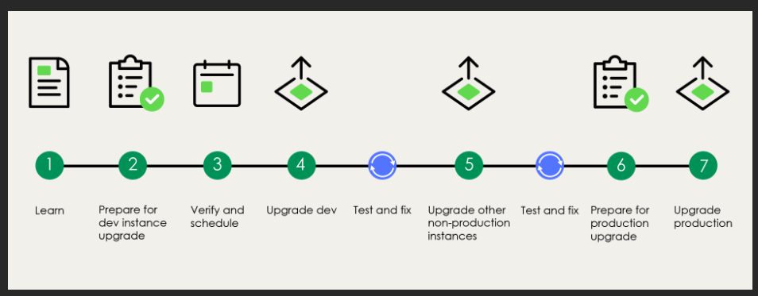

**Reference:** [**https://aws.amazon.com/blogs/industries/voice-applications-in-clinical-research-powered-by-ai-on-aws-part-1-architecture-and-design-considerations/**](https://aws.amazon.com/blogs/industries/voice-applications-in-clinical-research-powered-by-ai-on-aws-part-1-architecture-and-design-considerations/)